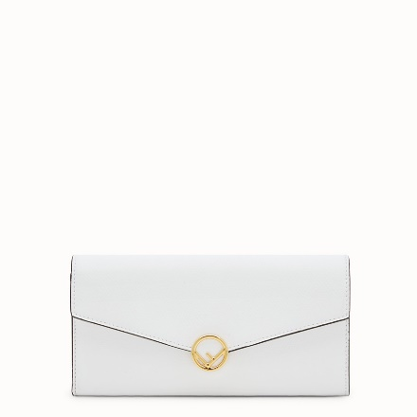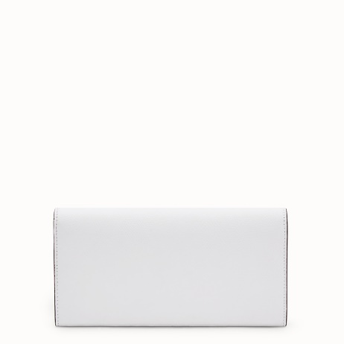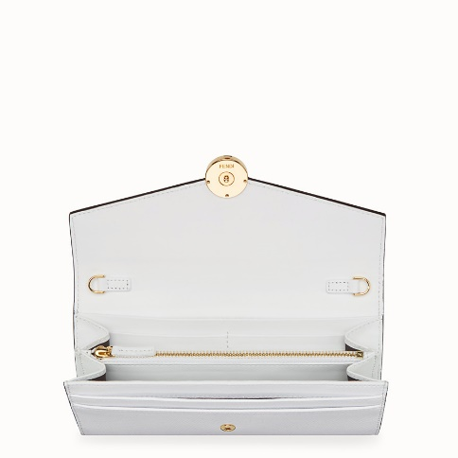

FENDI-CONTINENTAL WITH CHAIN

$850.00

COLOR :RED/PINK/BROWN/LIGHT PINK  
SIZE : ONE SIZE  
IN STOCK

[Detail](http://127.0.0.1:49618/content/lxdUQGKpHQbqUWULAAAC/HG3Y96M/iI6jSpj/WHR0kca/GYuu4S7/84sePXS/WKgHFye#collapse)

Continental F is Fendi wallet with slim detachable chain shoulder strap. Inside, it has two gusseted compartments, zip pocket, flat pockets and six credit card slots. Made of white cruise leather. Twist lock with the new Fendi logo. Gold metalware. Made in Italy.

• Length:7.5 inches

• Height:3.5 inches

• Depth:0.4 inches

• Composition:100% calfskin

Universal Style #: Product Code:8M0365A18BF01KW

[CARE & COMPOSITION](http://127.0.0.1:49618/content/lxdUQGKpHQbqUWULAAAC/HG3Y96M/iI6jSpj/WHR0kca/GYuu4S7/84sePXS/WKgHFye#collapse1)

• Leather

• Imported